Faculty of Engineering & Informatics



Breast Cancer Diagnosis Using Machine Learning

By
Omidu Jayasinghe
UB NO. - UB 24027835

University of Bradford
Table of Contents
Table of Figures 4
1. Introduction 6
1.2 Background 6
2. Dataset and metaset description 7
3. Cleaning and pre-processing of the dataset 8
3.1 Data integrity checks and column filtering 8
3.2 Correlation-based feature reduction 8
3.3 Train–test split and leakage prevention 8
3.4 Feature scaling and preparation of alternative datasets 8
4. Design of experiments for the data science solution 9
4.1 Experimental aim and overall strategy 9
4.2 Data partitioning and reproducibility controls 9
4.3 Preprocessing variants and controlled comparisons 9
4.4 Model benchmarking and selection rationale 10
4.5 Hyperparameter tuning and final model selection 10
5. Descriptive analytics methods and data visualizations 11
5.1 Summary statistics and class distribution 11
5.2 Individual feature analysis 11
5.3 Correlation analysis 13
5.4 PCA Analysis 14
6. Predictive analytics 17
6.1 ML Models 17
6.2 Hyperparameter tuning 18
7. Model Evaluation 19
7.1 Validation approach 19
7.2 Results of Predictive Models 19
7.2.1 Models with Standard Scaling (Z-score) 19
7.2.2 Models with Min-Max Scaling 22
7.2.3 Hyperparameter tuning 24
8. Discussion 25
9. Conclusion 26
Appendix 26
Fair AI Report 26

Table of Figures
Figure 1: Snapshot of the breast cancer dataset 6
Figure 2: Standard scaling 7
Figure 3: Min-Max Scaling 8
Figure 4: Summery of the Data set 10
Figure 5: Distribution of texture_mean Figure 6: Distribution of area_se Figure 7:Distribution of fractal_dimension_mean 10
Figure 8: Boxplot of texture_mean Figure 9: Boxplot of radius_se 10
Figure 10: Correlation Matrix 11
Figure 11: Elbow Plot 12
Figure 12: K-Means Clustering (PCA) 13
Figure 13: Agglomerative Clustering 13
Figure 14: dendrogram 14
Figure 15: Classification report Random Forest (Z-score) 17
Figure 16: Random Forest ROC Curve (Z-score) 17
Figure 17: Random Forest Confusion Matrix (Z-score) 17
Figure 18: Classification report SVM (Z-score) 17
Figure 19: SVM Confusion Matrix (Z-score) Figure 20: SVM ROC Curve Matrix (Z-score) 18
Figure 21:Classification report XgBoost (Z-score) 18
Figure 22: XGBoost Confusion Matrix (Z-score) 18
Figure 23: XgBoost ROC Curve Matrix (Z-score) 18
Figure 24: Figure 25:Classification report Extra Boost (Z-score) 19
Figure 25:Extra Boost Confusion Matrix (Z-score) 19
Figure 26: Extra Boost ROC Curve Matrix (Z-score) 19
Figure 27:Classification report Random Forest (Min-Mix) 19
Figure 28: Confusion matrix Random Forest (Min-Max) 20
Figure 29: Confution Matrix XGBoost (Min-Max) 20
Figure 30: Classification report XGBoost (Min-Max) 20
Figure 31: Confution Matrix report SVM (Min-Max) 20
Figure 32: Classification report SVM (Min-Max) 20
Figure 33: Confusion Matrix AdaBoost (Min-Max) 21
Figure 34: Classification Report AdaBoost (Min-Max) 21
Figure 35: Tuned Random Forest Classification report 21
Figure 36: Tuned Random Forest ROC curve 21
Figure 37: Tuned Random Forest Confusion Matrix 21
Figure 38: Tuned XGBoost Classification Report 22
Figure 39: Tuned XGBoost ROC Curve 22
Figure 40: Tuned XGBoost Confusion Matrix 22

Introduction
Breast cancers are the most common cancers affecting women worldwide, If these cancers identify right time increases the chances of accuratlly diagnosis and essential for improving treatment outcomes and reducing unnecessary invasive procedures. In clinical practice, diagnostic decisions are taken by multiple sources of evidence, including imaging and pathology. However, identification of complex patterns in biomedical measurements is challenging. Also, human judgement may be affected by variability and uncertainty. Data science offers another way by applying systematic analytics and machine learning. This can be used to identify informative patterns that support decision-making.
This study uses the Breast Cancer Wisconsin (Diagnostic) dataset. It has numeric features get from digitized FNA images and labels data as benign or malignant. Since can use supervised learning classification .
The aim of this work is to design and develop a AI-driven data science solution that has a complete pipeline. This includes data understanding, cleaning and preprocessing, exploratory analysis and visualization, ML model developing, testing and validation. Several machine learning models are created and compared them with same things. This makes fairness and reproducibility. Model evaluation is guided by clinically meaningful considerations: while overall accuracy is useful, performance metrics such as recall/sensitivity and ROC-AUC are emphasised because misclassifying a malignant case as benign can have serious consequences. This study is a validated predictive model and an evidence-based discussion.

1.2 Background
Breast cancer diagnosis often uses 3 main things clinical exam, imaging (mammography/ultrasound), and tissue sampling (FNA or core biopsy).(Gadgil et al., 2023) These things work correctlly. But those have limitations. Mammograms can miss cancers if there is dense breasts and can also give false alarms, leading to extra tests and sometimes unnecessary biopsies. (Limitations of Mammograms | How Accurate Are Mammograms? | American Cancer Society, no date)Pathology and cytology are partly interpretive. Because of that different people say different things on the same sample. Because of these uncertainties, machine learning can help by learning patterns from nucleus measurements and giving consistent, objective risk scores to support clinical decisions.(Saha et al., 2016)

Dataset and metaset description
This study is using Breast Cancer Wisconsin (Diagnostic) dataset(Breast Cancer Wisconsin (Diagnostic) Data Set, no date). It has numeric measurements derived from digitised images of fine needle aspirate (FNA) samples of breast masses. The predictive target is the clinical diagnosis label Diagnosis. It encoded as malignant (M) or benign (B), making the task a supervised binary classification problem. Each record corresponds to one case and includes an ID number used solely for identification (not prediction).
The dataset provides 30 real-valued predictive features that summarise characteristics of cell nuclei visible in the images. These features are based on ten underlying nucleus properties radius, texture, perimeter, area, smoothness, compactness, concavity, concave points, symmetry, and fractal dimension. For each property, three summary variants are included: the mean, the standard error (SE), and the “worst” value (typically representing the largest or most extreme measurements), resulting in 10 × 3 = 30 predictors. Feature values are recorded to four significant digits, supporting consistent numerical analysis.
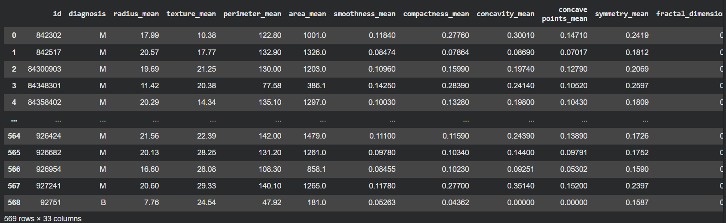
Figure 1: Snapshot of the breast cancer dataset
In the dataset there is no missing attribute values except one column. This simplifies preprocessing compared with many real-world clinical datasets. The class distribution is 357 benign and 212 malignant cases. This shows small class imbalance because of that need to be considered during model training and evaluation (e.g., stratified splitting and appropriate performance metrics).

Cleaning and pre-processing of the dataset

3.1 Data integrity checks and column filtering
The dataset was checked about its structure, data types, and completeness. First check the missing values of the dataset. This found one non-informative column, Unnamed: 32, which contained only null values. Since this column removed. Target definition and removal of non-predictive identifiers
The modelling target was defined as the diagnosis label (malignant vs benign). The ID attribute was excluded from the predictors because it is purely an identifier and does not encode biological information relevant to tumour classification. The diagnosis labels were then encoded into a binary numeric format to ensure compatibility with machine learning algorithms and evaluation metrics.

3.2 Correlation-based feature reduction
Before training the model, multicollinearity was checked using correlation analysis. Highly correlated features can add redundant information and affect some models. This also increase the model performance. A correlation threshold of > 0.98 was used to identify near-duplicate features. Based on this threshold, radius_mean, radius_worst, and area_mean were removed to reduce redundancy while keeping the remaining feature set for effective classification.

3.3 Train–test split and leakage prevention
The cleaned data set is divided into training and testing sets. Here used 80/20 split with stratification to preserve class proportions. A fixed random seed was used. This used to reproducibility. All transformations that learn parameters from data (e.g., scaling) were fitted only on the training set and then applied to the test set. This makes the correct generalization and reduce data leakage.

3.4 Feature scaling and preparation of alternative datasets
Because the dataset contains continuous variables with different magnitudes, feature scaling was applied to support fair model comparison and to improve performance for scale-sensitive algorithms. Two parallel(Feature Engineering: Scaling, Normalization and Standardization - GeeksforGeeks, no date) scaled versions of the dataset were created:
- Standard scaling (z-score normalization).
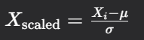
Figure 2: Standard scaling
- Min–max scaling, rescaling features to a fixed range.

Figure 3: Min-Max Scaling
Maintaining both scaled datasets enabled controlled experimentation across predictive models and supported descriptive methods such as clustering that rely on distance calculations.

4. Design of experiments for the data science solution

4.1 Experimental aim and overall strategy
The experimental design has two main outcomes.
- structured descriptive analysis: It is use to understand the dataset and inform modelling ways.
- development of a predictive classification: This is the solution that tested in a fair and reproducible manner.
In this design followed below workflow.
- data preparation,
- descriptive Analysis
- supervised learning model development and evaluation
- hyperparameter tuning of the models.

4.2 Data partitioning and reproducibility controls
To get unbiased machine learning model, the dataset divided in to two parts. Those are training and test sets using an 80/20 stratified split, maintaining benign/malignant class proportions across both partitions. A fixed random seed was applied to ensure reproducibility of the split and to stabilize comparisons between modelling choices. This approach ensures that all models are evaluated on the same held-out test data, enabling direct and fair performance comparison.

4.3 Preprocessing variants and controlled comparisons
The experiment used 2 feature scaling techniques. Each model compare with standard scaling and min–max scaling. This is justified because scaling can materially affect optimization and distance/margin computations and therefore impacts the performance of several commonly used classifiers. To keep comparisons controlled, both scaling methods were applied to the same train/test split, producing two parallel versions of the dataset that differ only in the scaling transformation.
To prevent data leakage, each scaler fitted only on the training data and subsequently applied to both the training and test sets. In addition, a correlation-based feature refinement step was included to reduce extreme redundancy identified during exploratory analysis. Specifically, a small set of near-duplicate features (correlation > 0.98) was removed to limit multicollinearity and reduce unnecessary dimensionality, while retaining a representative set of nucleus-based descriptors.

4.4 Model benchmarking and selection rationale
A broad set of supervised classifiers was evaluated to ensure coverage of different modelling assumptions (linear vs non-linear) and complexity levels (simple baselines vs ensembles). In the work multiple model types used, including linear based and tree-based ensembles. Each classifier was trained under the same experimental conditions (same split, same preprocessing variant) to ensure fairness. The detailed descriptions and justification of individual models are presented in Section f; this section focuses on ensuring the comparison itself is methodologically sound.

4.5 Hyperparameter tuning and final model selection
After initial benchmarking, the design includes tuning of the model parameters using RandomizedSearchCV with 5-fold cross-validation. Hyperparameter tuning (Hyperparameter Tuning - GeeksforGeeks, no date) is done improve performance of the model while reducing the risk of overfitting through cross-validated selection. The evaluation metrics used to compare models and select best one.
Overall, this design prioritizes reproducibility, leakage prevention, controlled preprocessing comparisons, and a clear progression from broad benchmarking to focused optimisation—supporting a robust and defensible data science solution.

5. Descriptive analytics methods and data visualizations
The section uses descriptive analytics to analyze the Breast Cancer Wisconsin (Diagnostic) data set and then make predictions. The objective is to provide a summary of the data, investigate the patterns and relationships among variables, and ensure that the observations form groups which may be associated with the benign/malignant labels.

5.1 Summary statistics and class distribution
descriptive statistics are the features that uses summary measures (e.g., mean, standard deviation, minimum/maximum, and quartiles). These canuse to get overall understand of the numerical data.
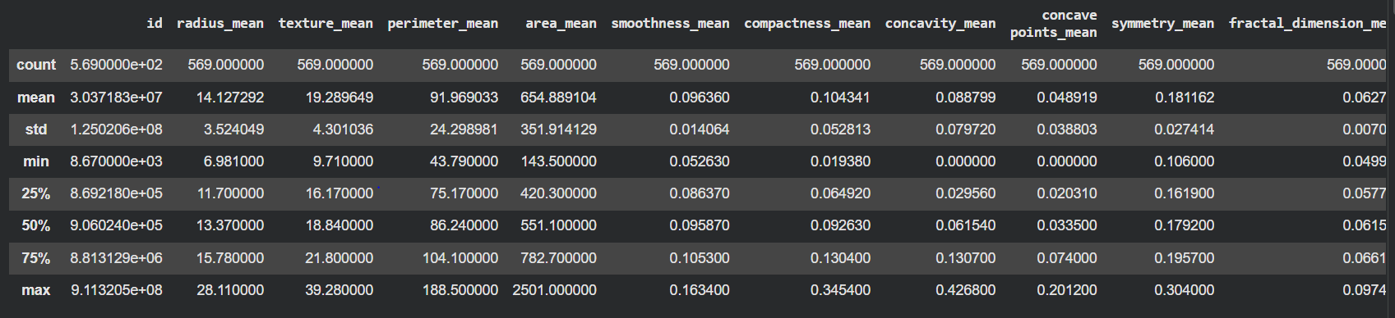
Figure 4: Summery of the Data set
Above figure gives 2 main takeaways
  - Several features are skewed.
  - There are wide range of features. Those can help to predict the diagnostic class correctly.

5.2 Individual feature analysis
To understand the individual features behavious by visually used 3 types of plots
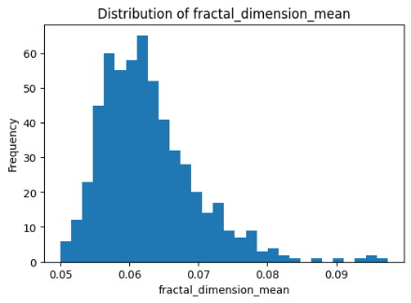
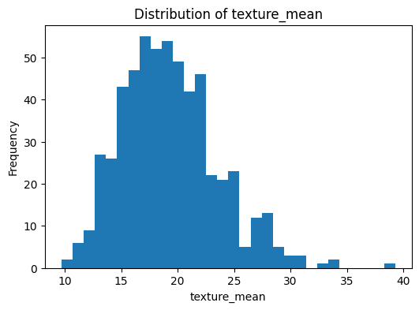
- Histograms: visualize the frequency distribution of each feature
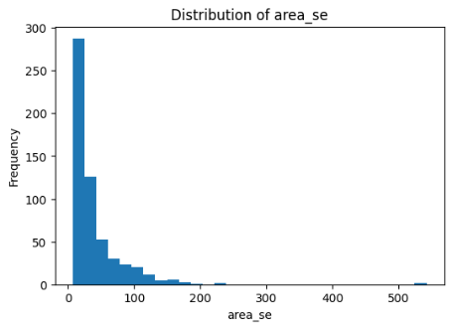

Figure 5: Distribution of texture_mean Figure 6: Distribution of area_se Figure 7:Distribution of fractal_dimension_mean
- Boxplots : show the median, spread, and possible outliers.
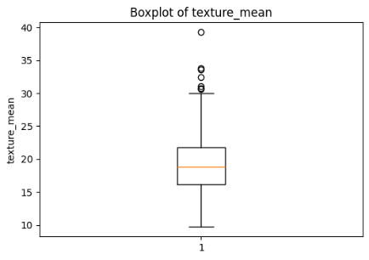
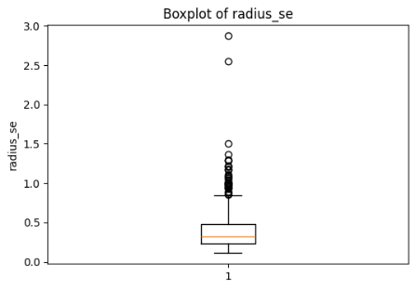

\

Figure 8: Boxplot of texture_mean Figure 9: Boxplot of radius_se
- Kernel Density Estimation: sed to give a smoother view of the same distributions
From the above 3 types of plots can get below key takeaways.
- Many features are not “normal” and are skewed.
- The histograms and KDE lines show that lots of variables are not bell-shaped. Many have more values on the low side and a long tail to the high side.
- There are outliers and the features with different scales.
- The boxplots show some extreme values in several features, and the spreads are very different across columns. This supports using feature scaling and using models that can handle outliers well.
The different feature ranges and outliers confirmed that scaling is necessary for distance/margin-based models (KNN and SVM). This is why I created two scaled datasets (StandardScaler and MinMaxScaler) and compared model performance under both.

5.3 Correlation analysis
For this data set gets the below correlation matrix.
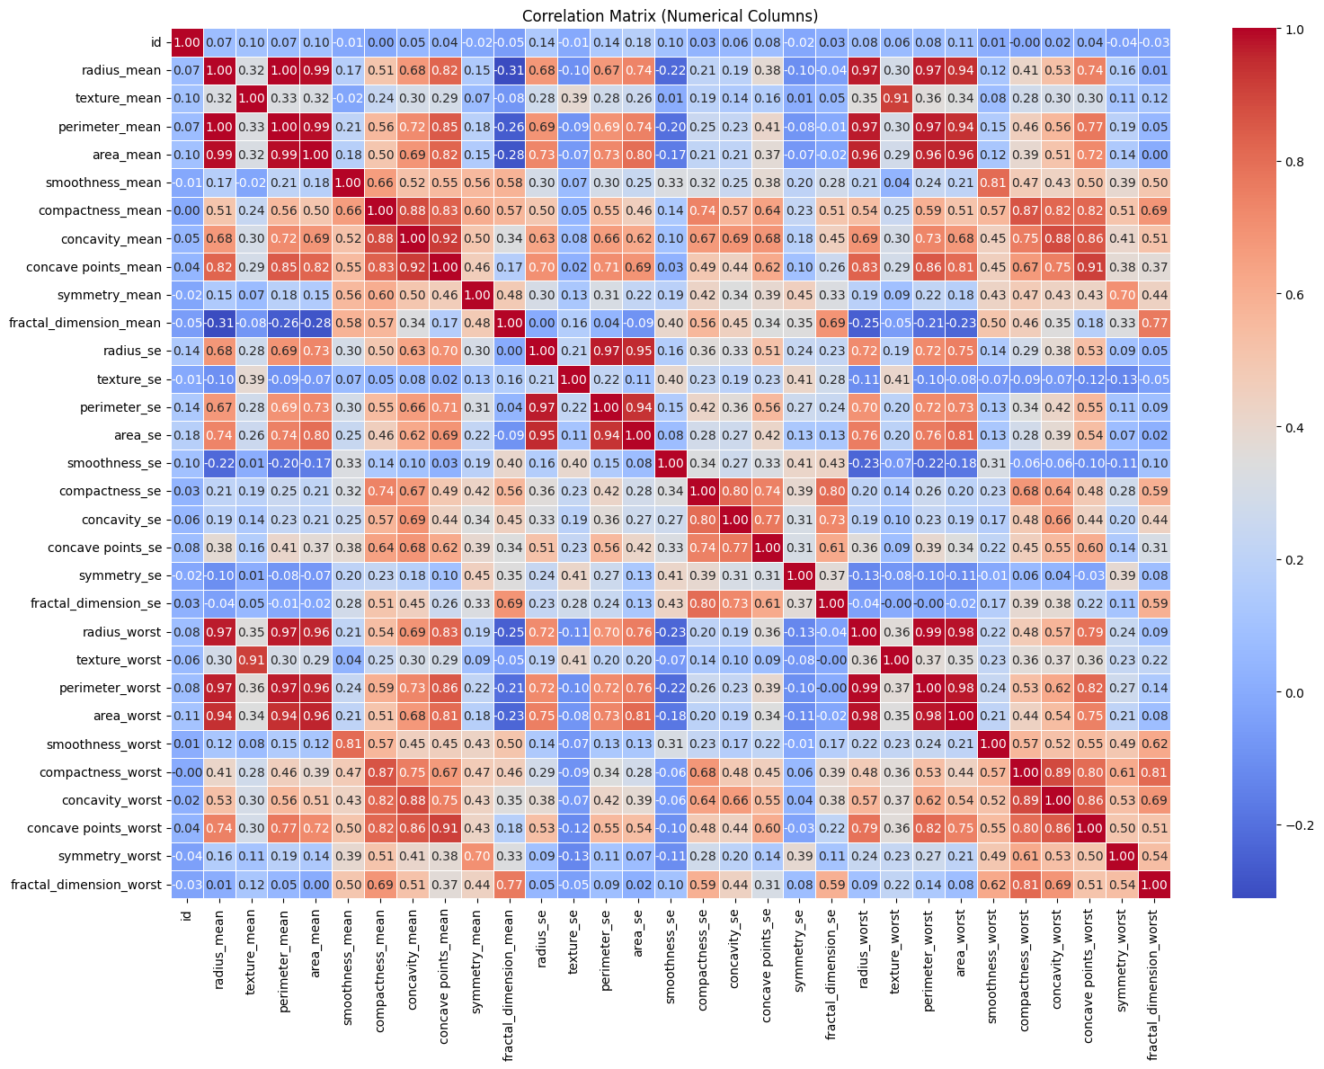
Figure 10: Correlation Matrix
Correlation Matrix shows many strong correlations, mostly size-related variables (radius, perimeter, area) and between the mean and worst versions of the same measurements. Several correlations are close to 1, which indicates multicollinearity (repeated information). This can make some linear model coefficients less stable and adds unnecessary features. Because of this response variables that has more than correlation of > 0.98 removed.
Two key takeaways from the correlation matrix
- Size-related features (radius/perimeter/area) are strongly linked and largely measure the same “tumour size” signal.
- Many mean and worst versions of the same feature are highly correlated.
- The correlation results showed many features repeat the same size-related information, so near-duplicate variables (>0.98) were removed to reduce redundancy and improve stability. This also influenced model choice by favouring tree-based ensembles (RF/Extra Trees/XGBoost)

5.4 PCA Analysis

Principal Component Analysis (PCA) is a method that reduces many features into a small number of new “summary” features called principal components. It keeps as much information (variance) as possible, but makes the data easier to visualise. In this notebook, PCA was used mainly to plot the dataset in 2D so we can see whether the cases form clear groups.
After scaling the features, the PCA scatter plot shows two main groups that are separated mostly along Principal Component 1. This suggests the dataset has a strong pattern that can help separate tumour cases, although there is still some overlap between the groups.
Two cluster analysis methods were used in this study
  - K-means clustering
K-means algorithm create clusters in the dataset by reducing the distance between data points and the cluster center. Scaling is important because it takes distance.

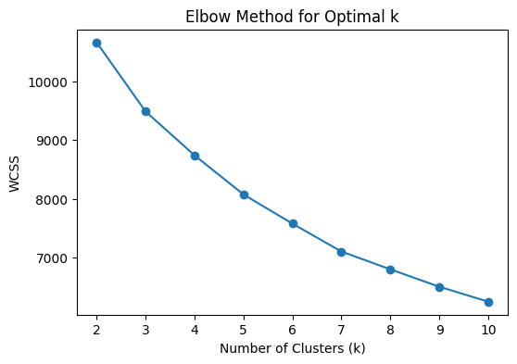
Figure 11: Elbow Plot
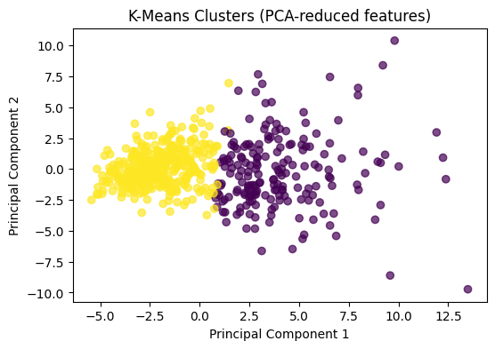
Figure 12: K-Means Clustering (PCA)

- The elbow plot (WCSS vs k) shows a strong improvement up to small k values and then the curve starts to flatten. This supports a simple structure, and k = 2 is a reasonable choice.
- PCA cluster plot, K-means creates 2 clear clusters. There is small overlap in the center. Overall those are separated.
- The K-means clustering performs good. Cluster is malignant (169 M vs 21 B) and Cluster 1 is benign (336 B vs 43 M).So data is divided in to 2 groups with limited errors.
  - Agglomerative (hierarchical) clustering
IN Agglomerative clustering, First this clustering consider each point as its own cluster. After that it merges the closest clusters step by step. It is useful because it can show structure at different levels.
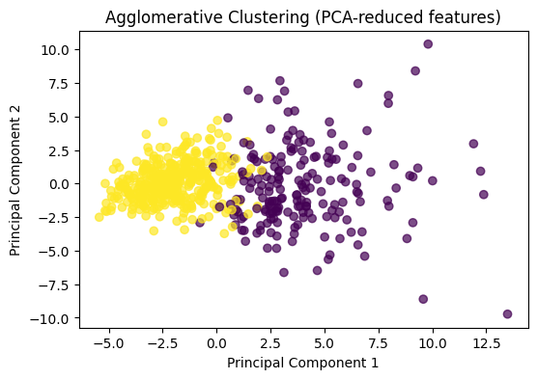
Figure 13: Agglomerative Clustering
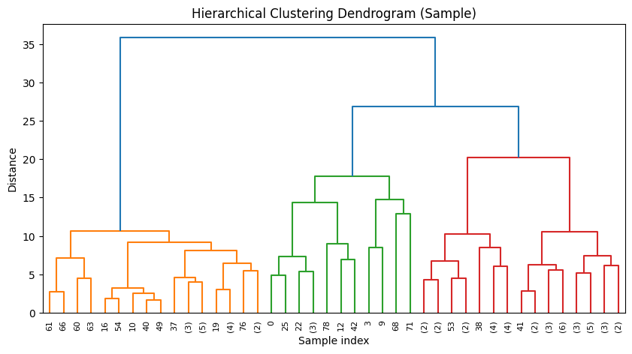
Figure 14: dendrogram
- The PCA cluster plot in here similar to to K-means. it also has two main groups, with a small overlap region.
- The dendrogram helps explain this: it shows how samples merge into larger groups over distance. You can see a few big branches, meaning the data has a clear grouping structure, with smaller subgroups inside it.
- Agglomerative clustering also aligns with the diagnosis. Cluster 0 is malignant (168 M vs 23 B) and Cluster 1 is benign (334 B vs 44 M). So here also, there is clear separation in the data with small overlap remains.
PCA showed two fairly clear groups, meaning the features can separate benign and malignant cases well. This supported using supervised classifiers and expecting good results. The overlap area showed some uncertainty, so ROC-AUC and probability scores were used to choose safer decision thresholds.

6. Predictive analytics
In the predictive stage, the Breast Cancer Wisconsin (Diagnostic) dataset is treated as a binary classification problem. The aim is to predict whether a tumour is benign (B) or malignant (M) using the numeric nucleus features. To support fair model training, two scaled versions of the data were prepared: one using standard scaling (StandardScaler) and one using min–max scaling (MinMaxScaler). This is important because several machine learning models are sensitive to feature size and distance calculations (Supervised Machine Learning - GeeksforGeeks, no date).

6.1 ML Models
- Logistic Regression (LR)
Logistic Regression was used as a strong baseline classifier.It learns a linear relationship between features and the target label and produces class probabilities. It is fast and simple machine learning model.
- Support Vector Machine (SVM)
SVM is performs well on dataset that has many numerical feature. Thats why its uses here. It tries to find a decision boundary with the largest possible margin between classes. SVM needs to scale variables to work well.
- K-Nearest Neighbours (KNN)
KNN is a sample ML model. It based on the labels of the closest training points. Because it relies on distances, feature scaling is essential. It is slow ML algorithem but its capture non-linear relationships in the data.
- Decision Tree (DT)
A decision tree divided data using the if elase conditions.It learns these conditions training the data. It can learn non-linear relationships well. It can easily understand . But there is a possibility of overfit.
- Random Forest (RF)
Random Forest is an ensemble Ml algorithem. It combines many decision trees. It reduces overfitting compared to a single tree and often gives strong performance on tabular data. It is less sensitive to scaling than KNN or SVM, but scaling was still applied for consistency across experiments.
- Extra Trees (Extremely Randomized Trees)
Extra Trees is like Random Forest, but it adds more randomness when creating splits. This can improve generalization in some cases and also provides feature importance estimates (Extra Trees | Medium, no date).
- Gradient Boosting (GB)
Gradient Boosting creates trees step-by-step. Every new tree tries to correct the errors made by previous trees. It can work with high accuracy, but it can lead to overfitting.
- AdaBoost
AdaBoost is also another algorithm of boosting that gives more weight to the previously misclassified samples. The method is also prone to noise and outliers though it could perform well.
- XGBoost
XGBoost is an advanced boosting method. This algorithem widely used for structured datasets. It includes regularisation and efficient training, and it often performs very well when the hyperparameters are tuned (XGBoost - GeeksforGeeks, no date).

6.2 Hyperparameter tuning
To improve performance the models, RandomizedSearchCV(Hyperparameter Tuning - GeeksforGeeks, no date) used with cross-validation. Only the two models tune the models because those 2 are the best performed when the first training happens. Those are Random Forest and XGBoost. This method is efficiency compared to other ones like gridsearchCV.
- Random Forest, hyperparameter optimization was focused on parameters like number of trees, the maximum depth, the minimum number of samples needed to split and create a leaf node, and the number of features considered during every decision point.
- In the XGBoost, the tuning parameters included the number of estimators, learning rate, and the depth of the tree makers and controlled model complexity and the strength of the learning signals.
In general, the use of a range of models, including the basic ones and advanced ensembles. This helps to create a solid comparative evaluation and helps identify a reliable predictive methodology in the classification of breast tumors.

7. Model Evaluation
To Evaluate models performance unseen(test data) data used. Because scaling can affect models, uses standard scaling and min–max scaling. The scaler is fit only on the training set and then applied to the test set to prevent data leakage.

7.1 Validation approach
Comparing models uses below metrics (Model Evaluation Techniques in Machine Learning | by Fatmanurkutlu | Medium, n..).
- Confusion matrix: gives number of correct and wrong predictions. It gives true positives, true negatives, false positives, and false negatives. This is important because predicting a malignant case as benign is a serious error.
- Classification report: gives precision, recall, and F1-score of each of the classes; recall, in that case, is the most important since it indicates the ability of the model to find malignant cases.
- Accuracy: gives the overall percentage of correct predictions.
- ROC curve: the ROC curve shows the trade-off between true positive rate and false positive rate at different thresholds.

7.2 Results of Predictive Models

7.2.1 Models with Standard Scaling (Z-score)
Best 4 ML models results are shown below.
- Random Forest
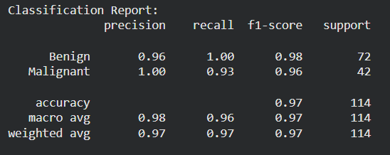
Figure 15: Classification report Random Forest (Z-score)
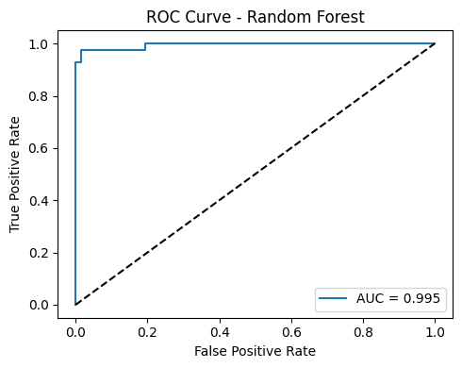
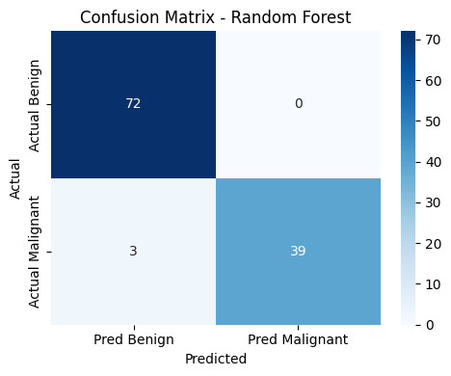
Figure 16: Random Forest ROC Curve (Z-score)
Figure 17: Random Forest Confusion Matrix (Z-score)
- Support Vector Machine (SVM)
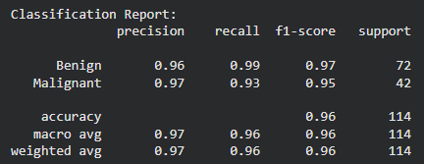
Figure 18: Classification report SVM (Z-score)
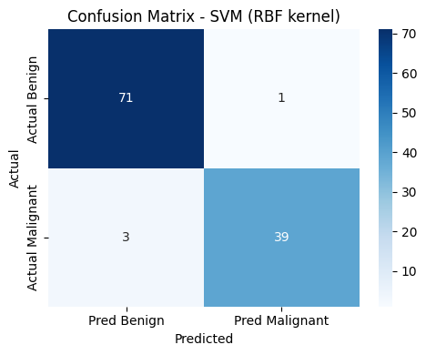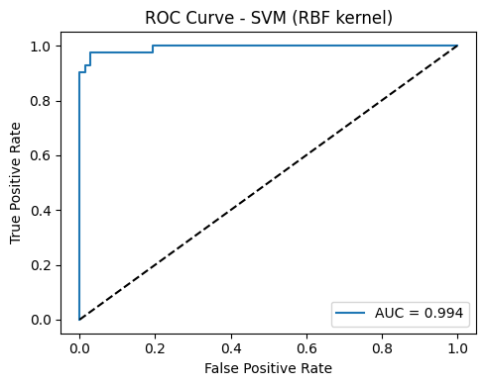
Figure 19: SVM Confusion Matrix (Z-score) Figure 20: SVM ROC Curve Matrix (Z-score)
- XGBoost
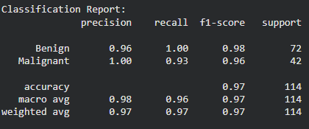
Figure 21:Classification report XgBoost (Z-score)
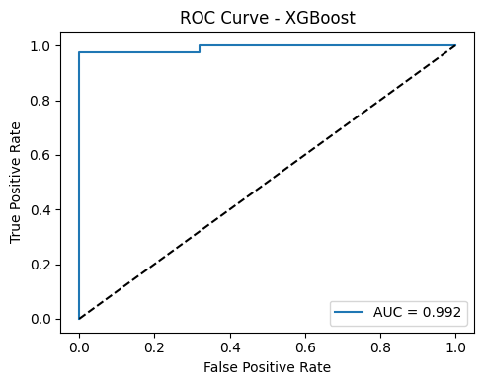
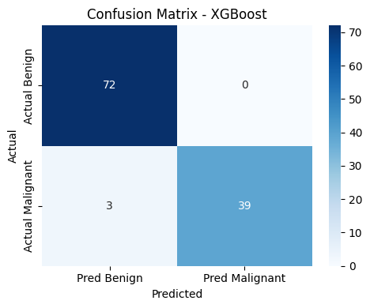

Figure 22: XGBoost Confusion Matrix (Z-score)
Figure 23: XgBoost ROC Curve Matrix (Z-score)

- Extra Trees
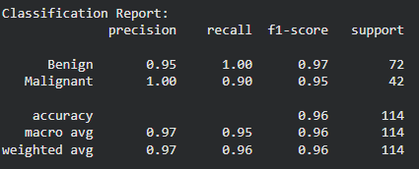
Figure 24: Figure 25:Classification report Extra Boost (Z-score)

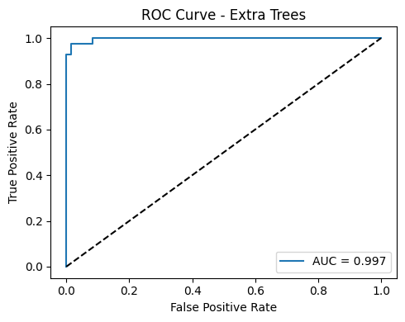
Figure 25:Extra Boost Confusion Matrix (Z-score)
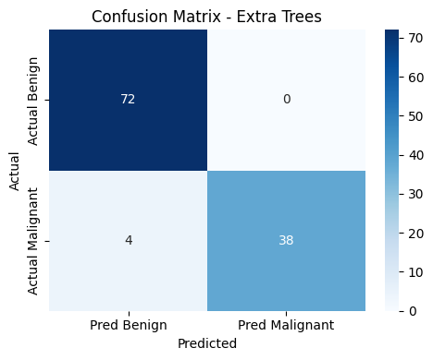
Figure 26: Extra Boost ROC Curve Matrix (Z-score)

7.2.2 Models with Min-Max Scaling
Best 4 models Results are shown below.
- Random Forest
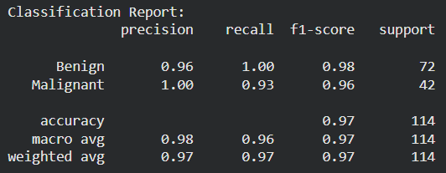

Figure 27:Classification report Random Forest (Min-Mix)

Figure 28: Confusion matrix Random Forest (Min-Max)

- XGBoost

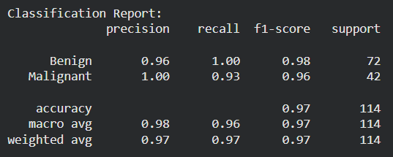
Figure 29: Confution Matrix XGBoost (Min-Max)
Figure 30: Classification report XGBoost (Min-Max)

- Support Vector Machine (SVM)
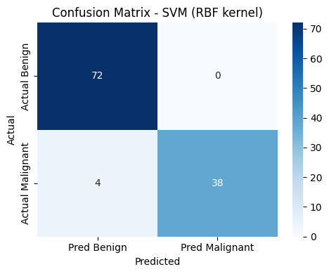
Figure 31: Confution Matrix report SVM (Min-Max)
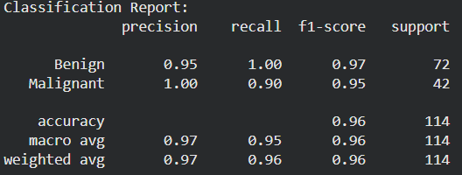
Figure 32: Classification report SVM (Min-Max)

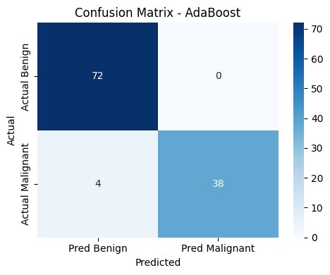
- AdaBoost
Figure 33: Confusion Matrix AdaBoost (Min-Max)
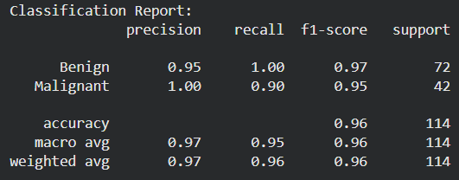
Figure 34: Classification Report AdaBoost (Min-Max)

From above results we can get best performing models are Random Forest and Xgboost, since those 2 selected for Hyper parameter tuning.

7.2.3 Hyperparameter tuning
- Random Forest
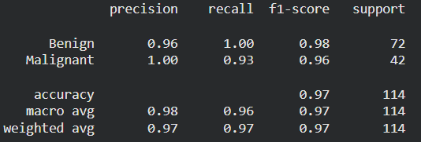
Figure 35: Tuned Random Forest Classification report
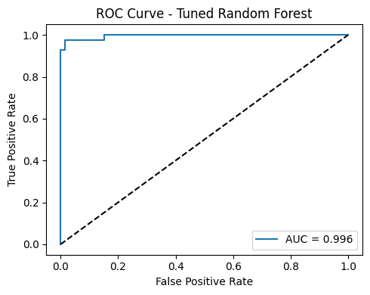
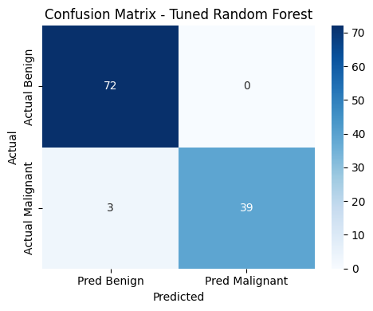
Figure 36: Tuned Random Forest ROC curve
Figure 37: Tuned Random Forest Confusion Matrix
- XGBoost
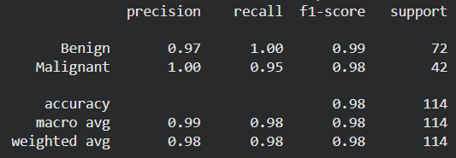
Figure 38: Tuned XGBoost Classification Report

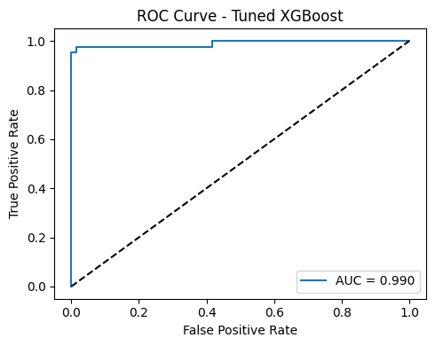
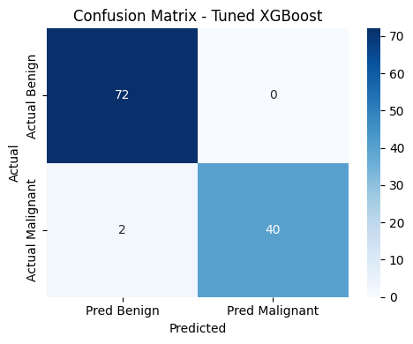
Figure 39: Tuned XGBoost ROC Curve
Figure 40: Tuned XGBoost Confusion Matrix

8. Discussion
Overall, nearly all of machine learning models get strong performance. This demonstrates that the data set contains definite trends of isolating benign and malignant cases. Random Forest and XGBoost models give highest teseting accuracy in this study. It gives the best at the baseline with the highest accuracy (0.97) but equally high malignant recall (0.93). That means those models correctly identified most malignant cases. SVM achieved 0.96 accuracy on the test set, with malignant recall reported in the classification report, showing effective separation between classes. Simple models like Decision Tree and KNN showed lower recall for malignant cases. This is not good for healthcare sector.
Hyperparameter tuning increases the model performance. The hyperparameter tuned XGBoost gets the best accuracy of 0.98 accuracy and 0.95 recall for malignant, reducing false negatives to 2 cases. Also hypeparamter tuned Random Forest gives accuracy of 0.97 and malignant recall 0.93. But that is not increse not tuned model performance.
In terms of efficiency, Logistic Regression and SVM are typically fast at inference and are easier to deploy. But those are weaker malignant detection than the best ensemble model. Tree-based ensembles (Random Forest/XGBoost) are more computationally expensive, especially during training and tuning. Those models give balance performance with high accuracy and low false negatives. Since XGBoost is the most suitable ML model.

9. Conclusion
The proposed solution achieved strong predictive performance for classifying breast tumours as benign or malignant. From the all the models, Random Forest and XGBoost are the best perfomed models. SVM also perform good (0.96 accuracy). After hyperparameter tuning, XGBoost gives the best results with 0.98 accuracy good malignant detection with 0.95 recall. It reduces the false negatives to 2 cases. These results get from the developed ML model pipeline. This includes the data cleaning, scaling, feature engineering, and model development process. It is an effective data-driven approach to the diagnostic classification problem, suitable as a decision-support prototype rather than a standalone clinical tool.

Appendix

Fair AI Report
Find – What AI have I used? | ChatGPT, Grammarly
Analyse – How have I used AI in this work? | I used ChatGPT to understand the data science workflow in detail (data understanding, preprocessing, EDA, model training, validation, and evaluation) and to clarify why each step is needed. I also used ChatGPT to identify reliable sources specially for the Background. It help summarise key points for referencing. ChatGpt used to find and fix coding errors. As example example, spelling mistakes in variable names that caused errors. I used Grammarly to correct grammer.
Inform – What effects has use of AI had in this work | AI improved my understanding of the end-to-end workflow and helped me write clearer explanations. It also reduced time spent searching for suitable background sources. All modelling, results, and metric values were generated and checked using my own code and outputs.
Reflect – Why did I choose AI?  What has the effect been on my learning? | I chose AI tools to strengthen my understanding of the full pipeline and to support academic writing. This contributed to establishing a fit between EDA results and the further presentation and modeling decisions as well as enabling me to obtain knowledge by applying, testing and imparting the models.

Reference
- Breast Cancer Wisconsin (Diagnostic) Data Set (no date). Available at: https://www.kaggle.com/datasets/uciml/breast-cancer-wisconsin-data (Accessed: December 26, 2025).
- Extra Trees | Medium (no date). Available at: https://medium.com/@samybaladram/extra-trees-explained-a-visual-guide-with-code-examples-4c2967cedc75 (Accessed: December 26, 2025).
- Feature Engineering: Scaling, Normalization and Standardization - GeeksforGeeks (no date). Available at: https://www.geeksforgeeks.org/machine-learning/feature-engineering-scaling-normalization-and-standardization/ (Accessed: December 26, 2025).
- Gadgil, A. et al. (2023) “Disrupting the Status Quo in Late Diagnosis of Breast Cancers in the Resource Limited Settings,” Medical Research Archives, 11(11). Available at: https://doi.org/10.18103/MRA.V11I11.4627.
- Hyperparameter Tuning - GeeksforGeeks (no date). Available at: https://www.geeksforgeeks.org/machine-learning/hyperparameter-tuning/ (Accessed: December 26, 2025).
- Limitations of Mammograms | How Accurate Are Mammograms? | American Cancer Society (no date). Available at: https://www.cancer.org/cancer/types/breast-cancer/screening-tests-and-early-detection/mammograms/limitations-of-mammograms.html?utm_source=chatgpt.com (Accessed: January 4, 2026).
- Model Evaluation Techniques in Machine Learning | by Fatmanurkutlu | Medium (no date). Available at: https://medium.com/@fatmanurkutlu1/model-evaluation-techniques-in-machine-learning-8cd88deb8655 (Accessed: December 26, 2025).
- Saha, A. et al. (2016) “FNAC Versus Core Needle Biopsy: A Comparative Study in Evaluation of Palpable Breast Lump,” Journal of Clinical and Diagnostic Research : JCDR, 10(2), p. EC05. Available at: https://doi.org/10.7860/JCDR/2016/15889.7185.
- Supervised Machine Learning - GeeksforGeeks (no date). Available at: https://www.geeksforgeeks.org/machine-learning/supervised-machine-learning/ (Accessed: December 26, 2025).
- XGBoost - GeeksforGeeks (no date). Available at: https://www.geeksforgeeks.org/machine-learning/xgboost/ (Accessed: December 26, 2025).

